* **This Networking Success Journal is the 3rd of 3 Success Journals in this Course. This Success Journal is the exercise book for Sections 42-50 of this course.**
* The purpose of this Success Journal is to make sure that you can successfully network to get meetings with people that work at the companies you are interested in working at or get meetings with potential customers.
* Please watch the videos in the course & then complete sections of this journal when instructed to do so.
* After completing this portion of the course (Sections 42-50) you will have the confidence to increase your chances of getting a job or customers by networking! No limits : ) Thanks

From the Course:

*The Complete Job, Interview, Resume, Network & New Career Guide*

Part 3 of 3: Networking

Success Journal

Your Blueprint

to Your Dream Job

Please use the PDF version of this document if you don’t have access to Microsoft Word or if you prefer a PDF formatted document for the device you are using to take this course. Thanks

Welcome to your **Networking Success Journal**! Please only complete the exercises in this journal when instructed to do so (meaning when I mention to please do so in the videos).

Please note that this “*Networking Success Journal”* is the 3rd of 3 journals in this course and corresponds to Sections 42 – 50 of the course.

I humbly recommend taking the course in order and completing the 3 Success Journals in order because you might learn what to include and what not to include on your resume and optimized LinkedIn profile based on how you answer the interview questions in Part 1 of this course. In addition, the optional goal setting workshop in Part 2 of this course might help you when it comes to pursuing a new career (via networking).

As always, I am here to help if you have any questions.

Enjoy the course! Thanks

Chris Haroun

: )

## **Section #42**:

## Networking: Now is the Best Time in Your Life & in History to Network

## **exercise #42:**

## setting up the premium subscription version of linkedin

In this exercise all I want you to do is sign up for the premium version of LinkedIn, which you can do by going to your profile and selecting try the premium version of LinkedIn for free, per this image:



We will use this premium service in future exercises to start setting up our informational networking meetings to help us get a job, get a customer or just network to understand if a certain career or industry is the right fit for you.

Now before we go on, please know that I am not affiliated with LinkedIn in any way at all (I have no business relationship with LinkedIn).

I just think that it is the best networking tool in the world and it has helped my career and my student’s careers tremendously.

Please see the next page for the next step.

Select the item on the left called Land Your Dream Job:



I will let you browse jobs and apply for jobs over LinkedIn yourself; it’s not helpful for me to teach you that as LinkedIn and YouTube searches can help you with this topic better than I can.

Rather, I want to help you network only. Again – apply to jobs if you want on LinkedIn, but I want to focus on teaching you how to get meetings by networking over LinkedIn as it works for me and has helped almost all of my in class business students that I teach during the evenings in the San Francisco Bay Area.

Please see the next page for the next step.

Next select ‘Start my free month’. You have 30 days to cancel before they charge you monthly. So if you want, set a calendar alert to remind you in 3 weeks or so to cancel.

Of course I don’t recommend cancelling as this networking goldmine will change your life. It has done wonders for many of my students over the past few years.



Please see the next page for the next step.

I want your profile to always be more complete and much better than your competition, which is what we focused on in Part 2 of this course. Please remember to be proactive in your new found journalism passion. Write often to increase your visibility.



Please see the next page for the next step.

Here is an interesting feature; per the image below, you can find out who has viewed your profile, meaning recruiters and others.

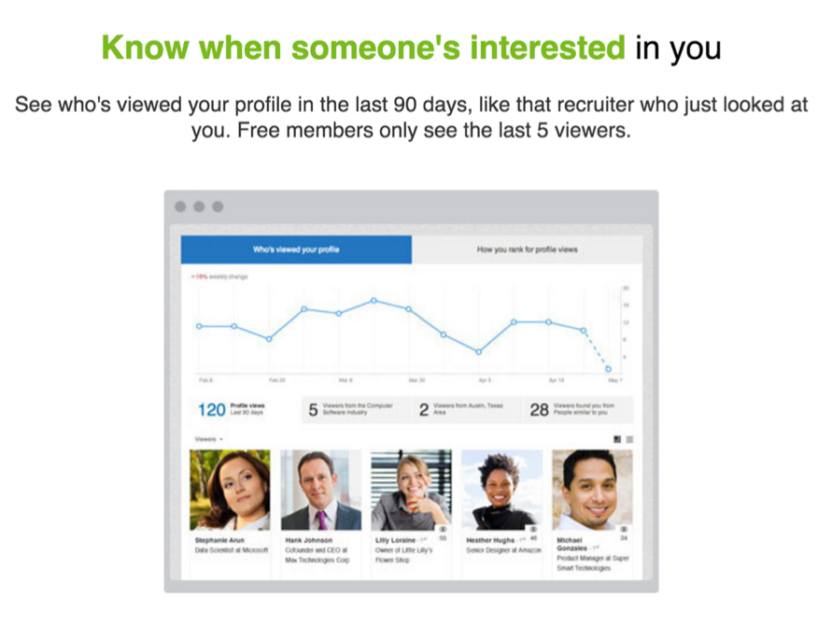

Please see the next page for the next step.

If you don’t want others to know that you are looking at their profiles, then after you sign up in this exercise, then mouse over the small image of you in the top right hand corner and select privacy settings:



Please see the next page for the next step.

Then select ‘Privacy’ at the top, then select ‘Profile viewing options’ and then change it to ‘Private mode’, which means all the person will see when you viewed their account profile is ‘Anonymous LinkedIn member’.



Please see the next page for the next step.

Another cool feature is that you can get recruiters to see your full profile so they can reach out to you which is of course optimal from a networking perspective, especially if potential employers or recruiters reach out to you.



Please see the next page for the next step.

Now this is the main tool that we are going to use and you will love it because you can reach out to literally anyone on LinkedIn using their messaging system which is called **inMails**. This is what we are going to use to get networking meetings in the remainder of the course; this is a networking game changer.

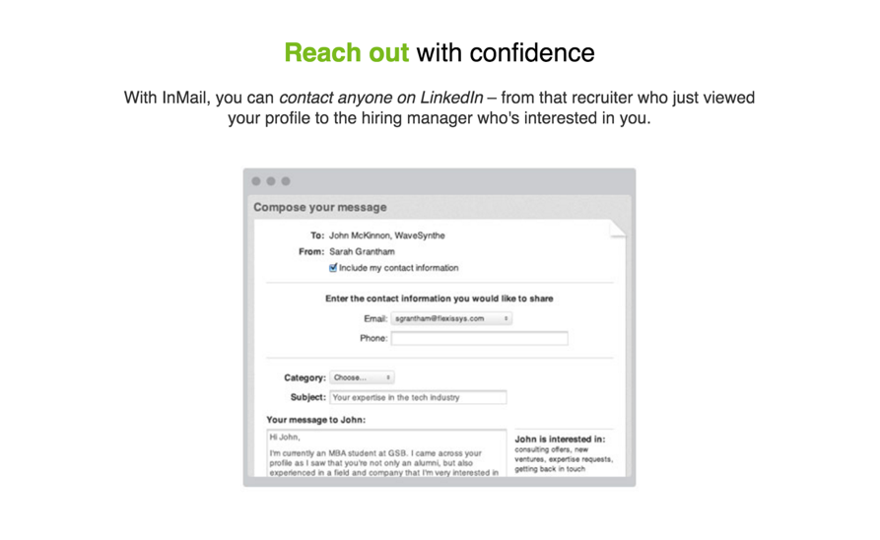

So please sign up for your 30-day free trial. Again you can cancel within 30 days.

Once you finishing signing up, I will see you in the next lecture and we will start networking.

**Next Step:** Please watch the next video in the course before doing the next exercise. Thanks

## **Section #43**:

## How Do We Get All of These Awesome Networking Meetings?

## **exercise #43:**

## Contacting 1 Person for a Meeting

In this simple exercise, please do an advanced search in LinkedIn and send someone an inMail that has at least 1 thing in common with you and they work in an industry or at a company that you might want to work at.

You need to be a premium LinkedIn subscriber to send most inMails. The first month is free and I really think a monthly subscription is the best networking and job search investment you can ever make.

Use the subject line and message content that we covered in this section and please make sure to list something you have in common.

Please put a reminder in your calendar that repeats weekly and never ends that reminds you to send one inMail per week.

**Next Step:** Please watch the next video in the course before doing the next exercise. Thanks

## **Section #44**:

## Maintaining Networking by Staying in Touch …How Can We Follow Up?

## **exercise #44:**

## Staying on Top of Career Moves

This exercise is very simple but I want you to always know where your contacts work because they change careers often.

Why do this? In case a contact you know works at a company you want to work at or at a company that you want as a customer.

Please go to My Network ad then select Connections.

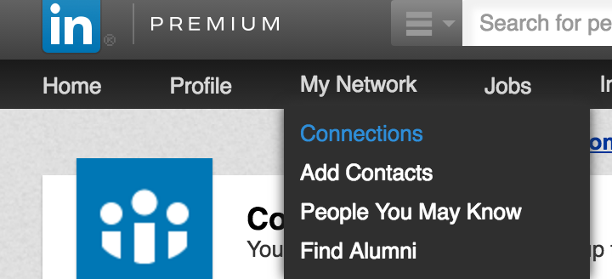

One last thing, please remember to go to your calendar and create a reminder to remind you to do this ‘connections exercise’ every 6 months (or every few months).

**Next Step:** Please watch the next video in the course before doing the next exercise. Thanks

## **Section #45**:

## Networking to Help You Change or Start a New Career

## **exercise #45.1:**

## Setting Up an Informational Meeting

In this exercise think about the career that you are considering switching to or if this will be your first job, then think about the industry you want to work in after school.

Please set up 1 informational interview at a company that you think you might want to work at.

Make sure that you understand **why** you want to work in this industry (call it industry x) and at the end of the informational meeting, ask yourself this question:

*“Why do I want to work in this industry?”*

If the answer doesn’t start with this:

*“I want to change careers and or work in this industry because I am very* ***passionate*** *about X…”*

then it’s not the right career change for you.

**Next Step:** Please watch the next video in the course before doing the next exercise. Thanks

## **Section #45**:

## Networking to Help You Change or Start a New Career

## **exercise #45.2:**

## Seeking a Mentor in a Different Department at your Firm

If you work at a company, please complete this exercise.

Earlier in the course we talked about the fact that when you receive a job offer, don’t take it until you see if the firm you are working at counters the offer or lets you transfer to another department.

The only way you can usually transfer to another department is if you have someone senior in another department fight for you which is how I have done it in the past.

Let’s be preemptive and strategic by networking within your company by meeting with people in other departments.

The easiest way to do this is to look on LinkedIn for people in your company in other departments that you might want to work for one day and see if they have anything in common with you.

Then, similar to what we have already covered, send them a LinkedIn message or email on your internal email system and set up a coffee meeting.

It’s a good idea in case your department ever gets restructured etc.

This exercise is to simply set up a meeting with someone in a different department at your firm and then ask them in person to mentor you. They will say yes because it’s an incredible complement. Networking of course is an internal career best practice too.

**Next Step:** Please watch the next video in the course before doing the next exercise. Thanks

## **Section #46**:

## Networking With Your Heart So You Can "Accidentally" Receive 10x > than You Give

## **exercise #46.1:**

## Using the ‘N.M.E.’ (‘network Match Equation’) Strategy

There are 2 parts to this exercise.

1: The first exercise deals with qualities that got you a date with someone you thought was out of your league meaning you thought they were too good for you.

2: The second exercise deals with how to get people you are going to meet with in business think that you are out of their league.

|  |
| --- |
| **Exercise 1:** Think of a time when you were on a date and you thought you were way out of your league (meaning you thought “why would they date me?”). This person you are on a date with is a 10 and you (for this exercise) are a 1. List at least 10 qualities why the other person thought of you as being equal to or greater than a 10 so that the Networking Match Equation brings you at least in balance: |
| 1: |
| 2: |
| 3: |
| 4: |
| 5: |
| 6: |
| 7: |
| 8: |
| 9: |
| 10: |
| 11 (Come on list one more…let’s push the goal post out!): |

|  |
| --- |
| **Exercise 2:** Think of a person you are going to meet with in business or you want to ask them to meet with you for the first time. They are a 10 and (for this exercise) you are a 1. List at least 10 qualities why the other person will think of you as being greater than a 10 so that the Networking Match Equation brings you at least in balance (why is it very beneficial for them to have the pleasure of meeting you!): |
| 1: |
| 2: |
| 3: |
| 4: |
| 5: |
| 6: |
| 7: |
| 8: |
| 9: |
| 10: |
| 11 : ) |

**Next Step:** Please watch the next video in the course before doing the next exercise. Thanks

## **Section #46**:

## Networking With Your *Heart* So You Can "Accidentally" Receive 10 TIMES MORE THAN WHAT YOU GIVE IN THE LONG RUN

## **exercise #46.2:**

## Setting Up A Meeting to Mentor Someone

This exercise will give you the most pleasure and peace of mind and fill your heart up with love and happiness:

* I want you to find someone and mentor them.
* It can be a younger cousin who is going down the wrong path in life.
* It can be one of your employees that you don’t know that well.
* It can be a random email from someone that you received a while ago asking for help that you never bothered to answer. Reply to that email today.
* Start mentoring them and many others as it will help you in so many ways. It will make you feel amazing – like the high you get and feel when you are leaving the gym.
* It will also help to remind you of what your core values are and what your recipe for success is as you will more likely be able to practice what you preach after these M.O.O. Meetings (Mentoring of Others Meetings)….catchy name eh! …because I want you to remember this forever : )

**Next Step:** Please watch the next video in the course before doing the next exercise. Thanks

## **Section #47**:

## Networking Success Journal Exercise #47: Meeting with these 10yr Goal Achievers!

## **exercise #47:**

## * Finding People that Achieved Your Work, Education and Personal 10 year Goals

*If you created your 10 Year perfect resume earlier in this course, then I want you to find people using LinkedIn that are living your 10 year dream and look at what they did in between to achieve that dream. Copy them. Also ask to meet them.

Break up your simple perfect 10-year resume that you created in Section 25 into 3 parts. Meaning your work, education and personal (the 3 sections on your resume).

Over the next 10 weeks, network to meet or speak with 10 people that achieved your goals in each category.

This means 10 people that achieved your 10-year **Work** goals.

In addition, meet 10 people that achieved your 10-year **Education** goals.

Lastly, meet 10 people that achieved your 10-year **Personal** goals.

They are living your dream in 10 years today! Who better to ask on how you can achieve these goals than them? They will feel flattered when you ask them for help.

There are hundreds of people on LinkedIn and all you have to do is search for them using the advanced search strategy we spoke about in great detail earlier in this course. Please don’t forget to search and find **something in common** with these people so that your **short inMail** is optimized.

Please keep in mind the exercise that we did in the cover letter section of the course when you thought of the future you getting asked by the present you for a meeting (Section 32).

There are so many people that have your dream resume in 10 years that want to help you. Many of them got there by having a big heart so ask them! They were you one day. They don’t forget how hard it was for them and they will appreciate how hard it is for you. Contact them. Why? Because nobody else will.

*\* Optional: please consider going back to Section 25 and completing the empowering goal setting workshop in that section. : )*

**Next Step:** Please watch the next video in the course before doing the next exercise. Thanks

## **Section #48**:

## Networking + General Strategies if Have No Idea What to Do and/or if You're a Student **exercise #48:** Did People in Strategies 1-4 in this section Make it Later in life?

Similar what we did in the video lecture lessons in this section searching LinkedIn looking for people that were in the Peace Corps and what did they do later in life, please pick a few jobs or degrees or volunteer jobs and see if people that did those things earlier in their life are in a position that you want to be in one day. Look at their LinkedIn profiles.

**You set your own path in life…but seeking guidance from others or observing the career paths of others that did what you want to do can help you crystalize your goals and find your *path, purpose and passion*.**

**Congratulations**!!!! You are now better prepared than literally anyone that has ever interviewed at the company you will be interviewing with (VERY TRUE). This should give you the confidence to enjoy and do exceptionally well in your interview! Also, your resume and LinkedIn profile will do wonders for your career; please enjoy publishing articles on LinkedIn. Lastly, please enjoy networking as you take your career to the next level (‘*meet people, have fun and learn’*)!

There are no limits to what you can achieve!

Thank you very much for your time, dedication and commitment,  
Chris : )



**Please find your passion and live love life on your terms.**